**Add Manex PN to BOM**

This module will help you populate Manex P/N from Manex BOM to Customer BOM by mapping the RefDes. It is very tedious work to find Part Numbers of a specific designator from all the Part Numbers of various RefDes from the Manex BOM. Not only that, once you find them, you also have to look for duplicates if any.  
  
In order to lessen your work, we have brought this feature that will fetch the Manex BOM as well as Customer BOM of a specific customer and populate the Manex P/N with indicating discrepancies if any. **This will save you a lot of time, which you can utilize for other significant tasks instead.** It also highlights records of Manex BOM that has no match or the records that Customer BOM finds as duplicates, so that you can easily compare and save time analyzing the whole BOM.  
  
There is one more perk of using this app. You can directly use the BOM sent by the customer without the need of renaming because this feature will do that for you.

#### **Detailed Features**

* It appends the work order number in the customer BOM file name.
* It reads both excel files and maps the RefDes from both the BOMs.
* It uses delimiters to segregate all the RefDes of a record for comparison.
* It also uses separators if any to predict the undefined values of designators.
* You are only needed to provide the Manex BOM and Customer BOM excel files.
* In addition, just few details of the Customer BOM is to be filled.
* It has the mechanism to predict Manex BOM details so you need not provide those.
* Once the program is executed you can find the Manex P/N populated in the Customer BOM with few significant highlights in both excel files.
* The feature will add 2 columns at the beginning, one with the Manex P/N and other to display any discrepancies using different highlights.
* The highlight column is just for easy analysis which can be got rid of after proper scanning and validating the data.
* Highlights in Customer BOM:
  + Yellow - Manex P/N not found
  + Blue - Duplicates
  + Red Font - For quantity 0
* Highlights in Manex BOM:
  + Red - Manex P/N not utilized
  + Blue - Duplicates

**Set Up**

Firstly, you need to make sure that you have both Customer BOM and Manex BOM downloaded in your system. The Manex BOM will be of format .xlsx but the Customer BOM may vary - it can be .xlsx or .xls. You can easily identify format differences with the icon. But you don't have to worry, we have handled both versions correctly in our module.

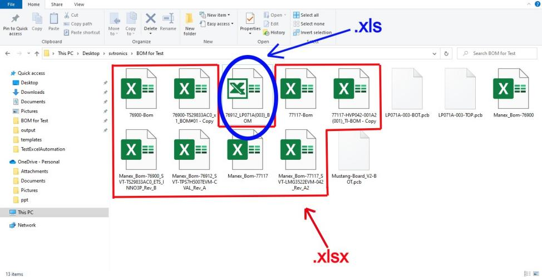

Not to forget to make sure that Customer BOM is available on the first sheet of the excel workbook else just move it to the first place. **Now, you are completely ready to utilize this feature!!**

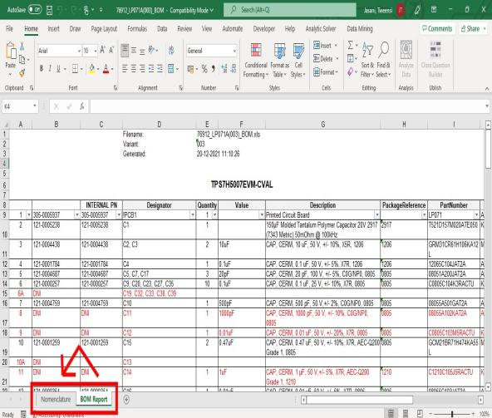 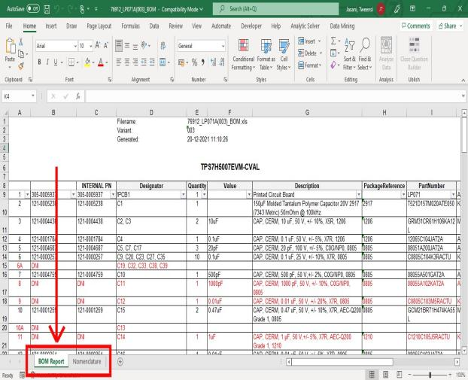

#### **Workflow**

The unmodified Customer BOM looks like this……

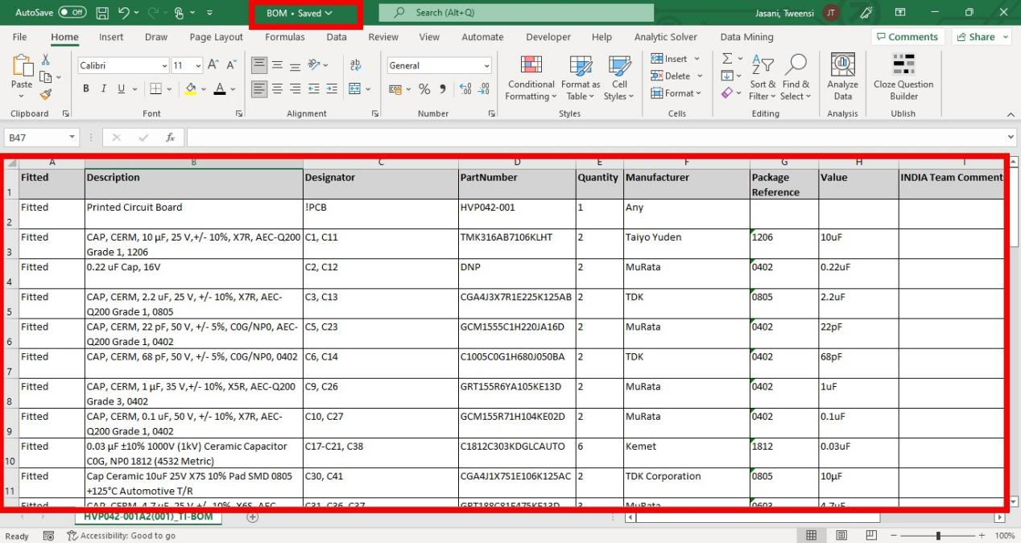

The unmodified Web Manex BOM………

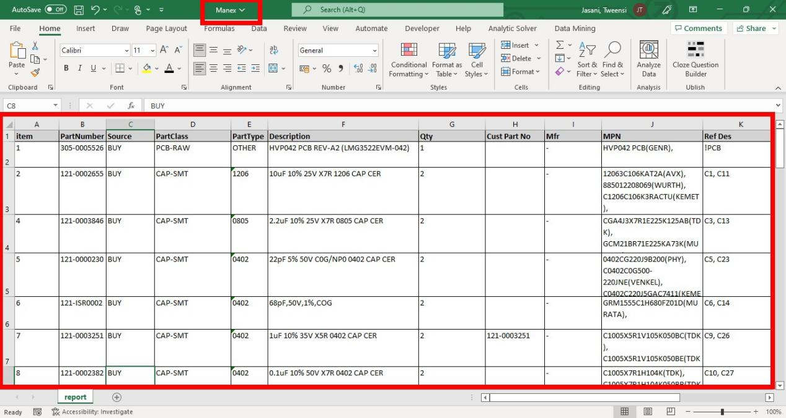

**Let’s begin the execution….**

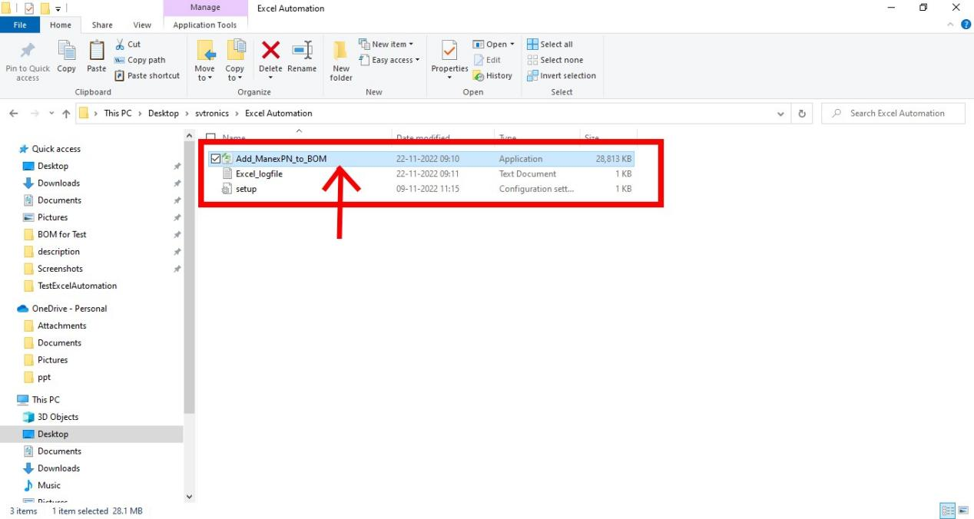

Select the Web Manex BOM.

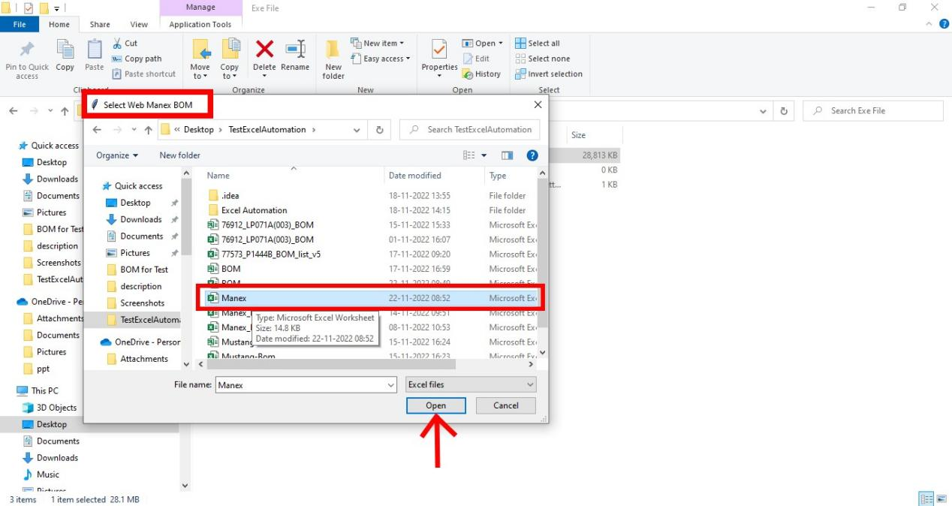

Select the Customer BOM.

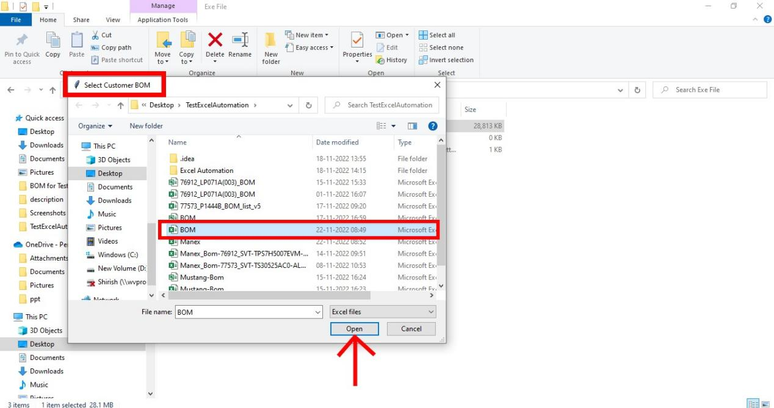

Fill in the details regarding Work Order Number and customer BOM columns. **Here, the Work Order Number is used to rename the Customer BOM.** If you have already renamed the BOM with Work Order Number, leave it blank.

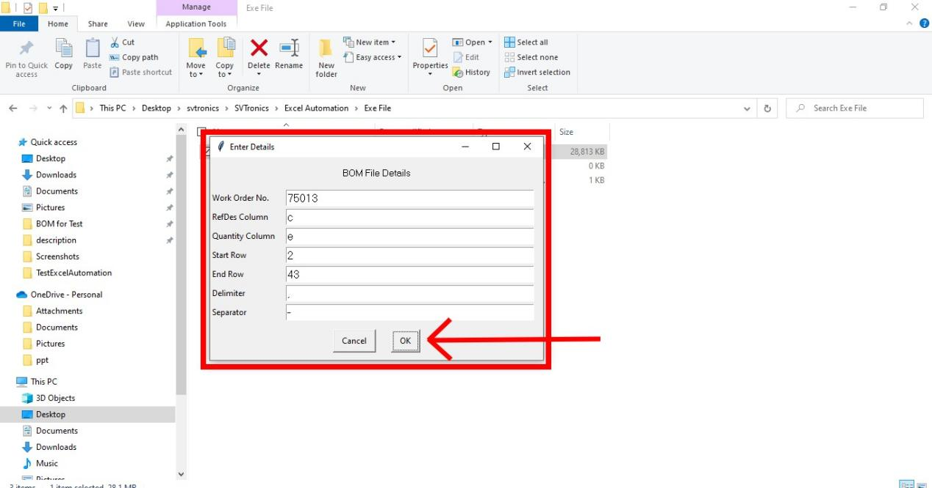

Now to make sure there is no permission denied conflict while writing on the excel files, you need to close both the files before proceeding further. **Hit OK on the dialog box only after you have the files closed.**

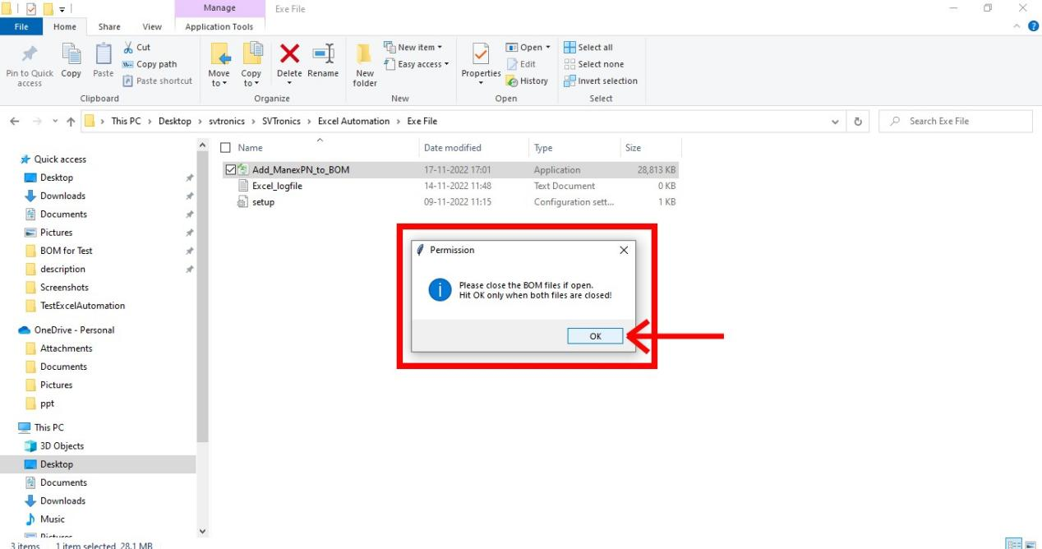

Now, if the BOM has separators, it will ask you to confirm an instance identified with the separator. **For the Manex BOM, it will automatically populate the intermediate values,** but for Customer BOM we have kept this feature to be utmost sure about the expansion of RefDes.

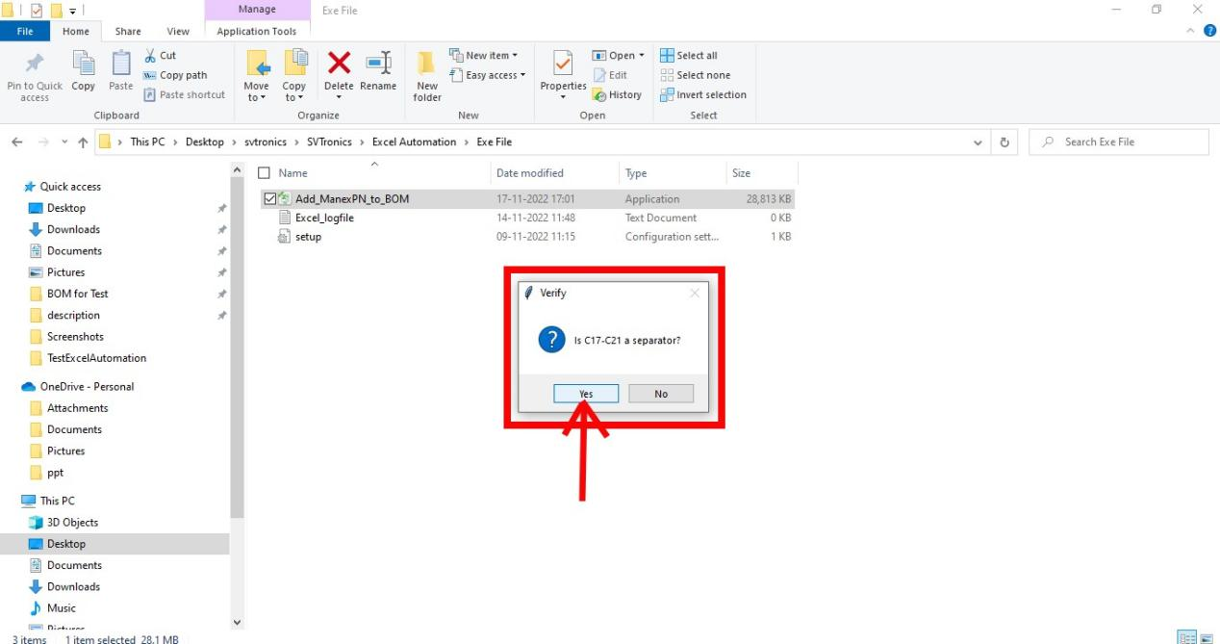

If yes, then it will ask you to specify the base and the range.

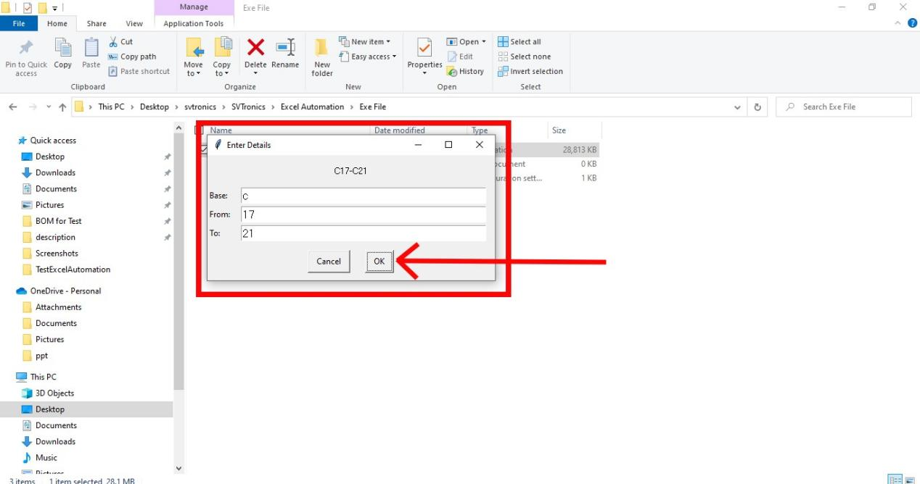

Once you complete, it will again show you the expanded values for confirmation.

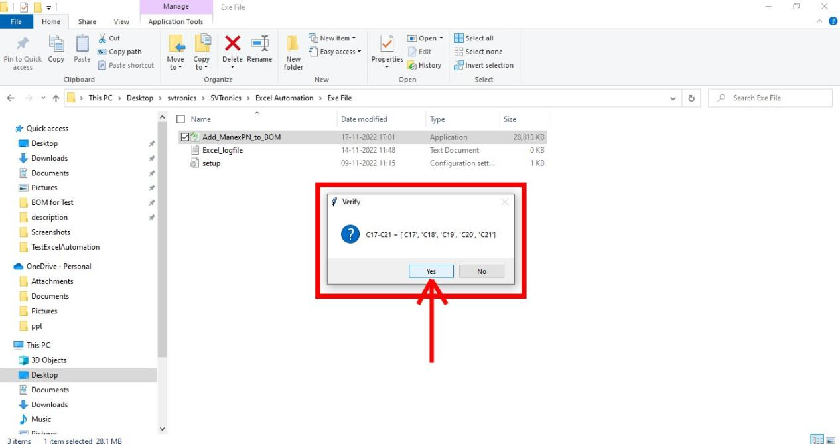

**That’s it!** The process is completed.

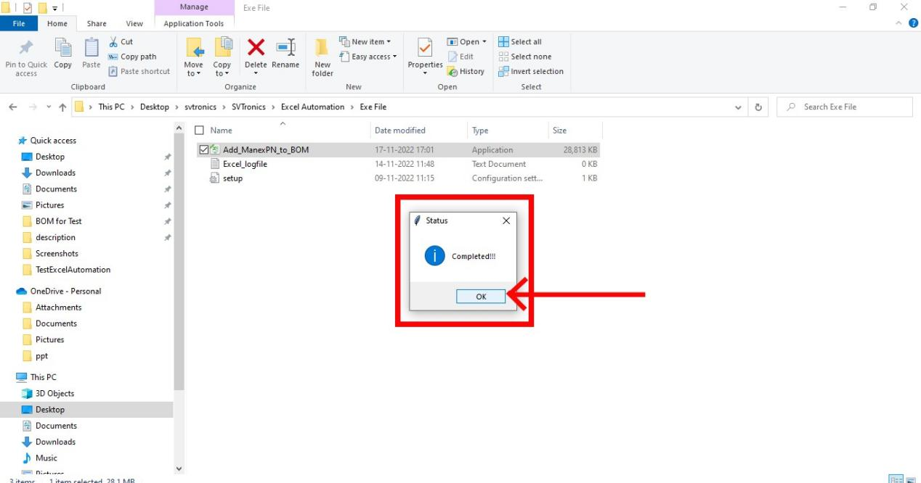

**Let me help you with the markings on both BOMs.** First of all, the Customer BOM is now renamed with the Work Order Number. Also, you will see 2 columns inserted in the starting, first for stating discrepancies and the second with the Manex P/N.

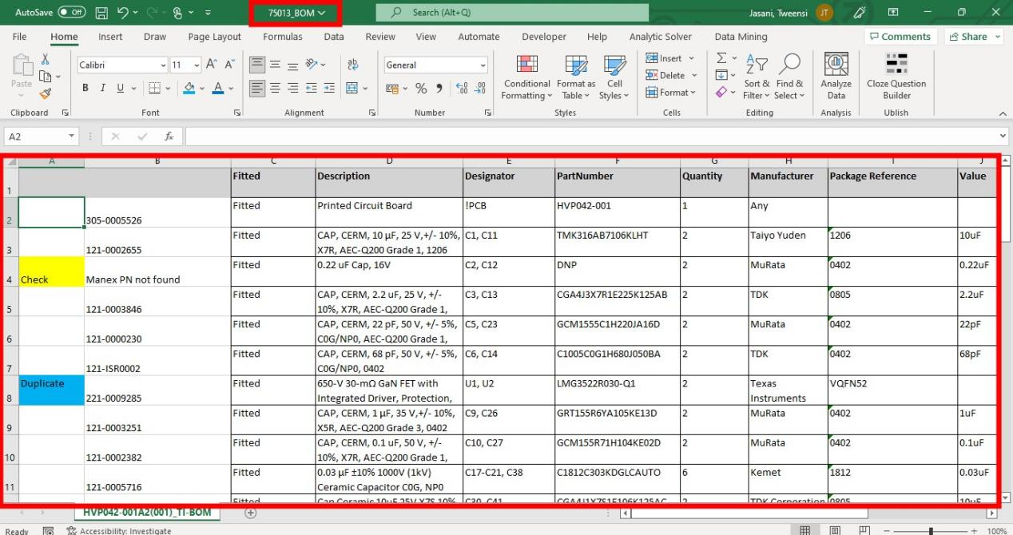

If there is no match for the RefDes of Customer BOM in Manex BOM, then it will be **highlighted to yellow**, but if it identifies more than one match then it will be **blue highlighted**. On the other hand, if the quantity in the Customer BOM is 0, then that row would be marked with **red font**. **Now, to keep track of the execution, it leaves a timestamp at the end.**

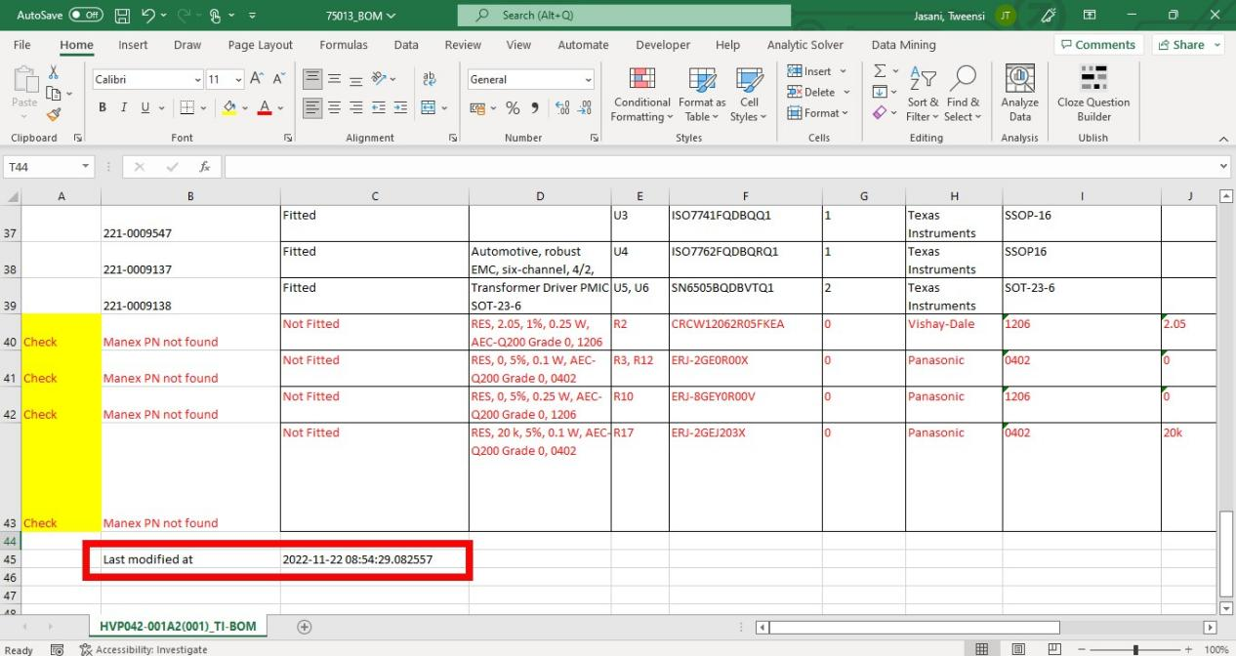

Once you analyze the discrepancies, you can get rid of the first column. **Select and Delete.**

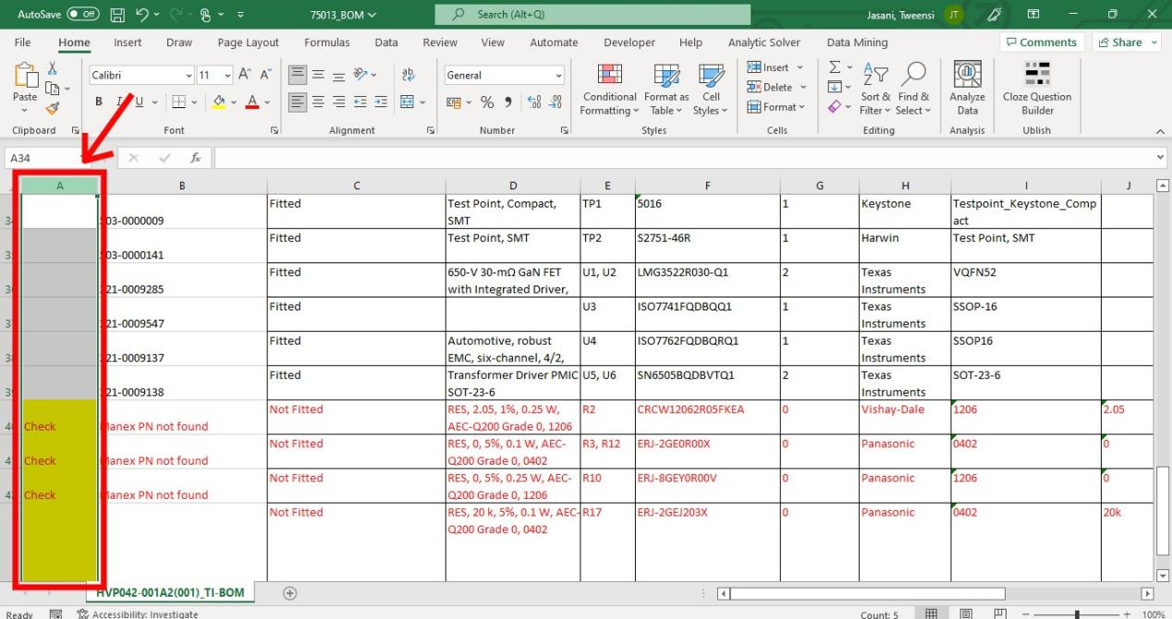

The Manex BOM has only two kinds of markings. **Red font** represents the unused Manex P/N and the **blue fonts** represent duplicates.

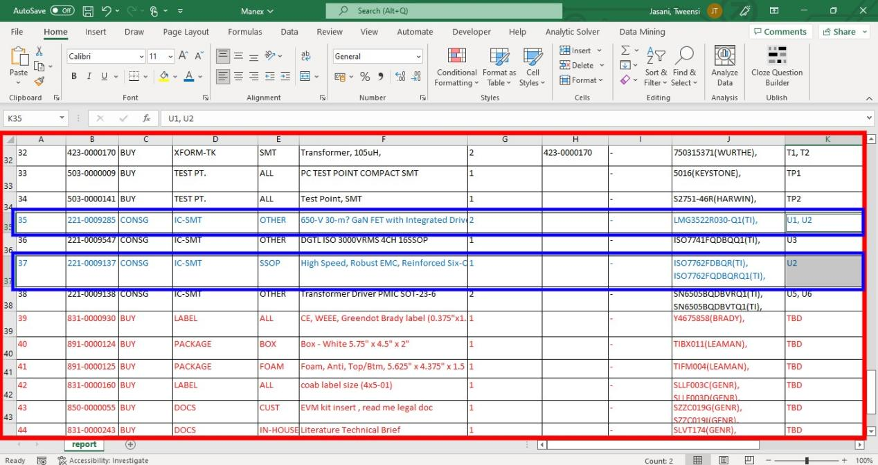

**And you have your tedious task done just like that!!….**